THE UNIVERSITY OF AZAD JAMMU AND KASHMIR, MUZAFFARABAD
DEPARTMENT OF SOFTWARE ENGINEERING

LAB INSTRUCTOR: ENGR. ZEESHAN

“PERSONAL FINANCE MANAGEMENT SYSTEM”
SUBMITTED BY:
AYESHA AKRAM 2024-SET- 07
ROMAAN HAFEEZ 2024-SET-38
ROMAN SHABIR 2024-SET-37
UME HABIBA 2024-SET-24

Lab Title: | Programming Fundamentals
Course Code: | CS-1101
Semester: | 1st
Session: | 2024-2028

Table of Contents
1. Introduction 3
2. Objectives 3
3. Features 3
4.Technologies used) 4
5. system design 4
1.Data structure 10
2. Functional modules 11
6. User interface 11
7.Code Execution Flow 15
1. INTRODUCTION: 3
2. OBJECTIVE: 3
3. FEATURES: 3
4.Technologies Used: 4
Step by step explanation: 8
Step 1: Including Necessary Libraries 8
Step 2: Defining Constants and Structs 8
Step 3: Declaring global variables 8
Step 4: Defining functions 8
Step 5: main function 8
output 8
8.limitation and future improvement. 16
1.limitations 10
2.Future improvements 10
6. Conclusion 16

1.INTRODUCTION:

The Personal Finance Manager is a simple console-based application that helps users track their incomes, expenses, and savings goals. The program provides a straightforward way to manage personal finances by recording transactions and calculating balances.

2.OBJECTIVE:

- The main objectives of this project are:

- To create a simple financial management tool.

- To allow users to log incomes and expenses.

- To calculate total income, total expenses, and current balance.

- To set and track savings goals.

- To present financial summaries in an easy-to-read format.

3, FEATURES:
The application includes the following features:

1. Add Income – Users can log their income by providing a date, category, and amount.

2. Add Expense – Users can record their expenses with a date, category, and amount.

3. Set Savings Goal – Users can define a savings target they aim to achieve.

4. Display Summary – The system displays all financial transactions, total income, total expenses, current balance, and progress towards the savings goal.

5. Exit – Allows users to exit the application.

4.Technologies Used:
Programming Language: C++

Concepts Used: Structured Programming, Functions, Arrays, Conditionals, Loops

5. System Design

  - 1 Data Structure

The program uses a structure (struct) named FinanceEntry to store financial records.

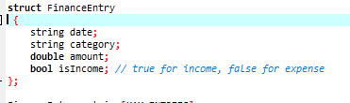
An array of FinanceEntry is used to store multiple transactions.

  - 5.2 Functional Modules

1. Adding Entries (Income/Expense)

Function addEntry(bool isIncome) allows users to add an income or expense record.
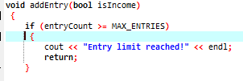

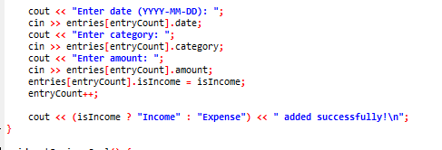

It checks if the maximum limit is reached.

It takes user input for date, category, and amount.

It stores the data in an array.
  - 2. Calculating Balance

Function calculateBalance() calculates the current balance.

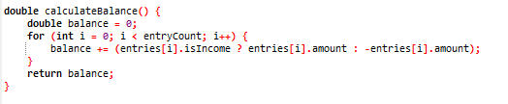
It iterates through all records and updates the balance accordingly.

  - 3. Setting a Savings Goal

Function setSavingsGoal() allows users to set a savings target.

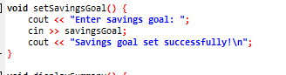
It takes the savings goal as user input and stores it.

  - 4. Displaying Financial Summary

Function displaySummary() shows a detailed report of transactions, income, expenses, balance, and savings progress.

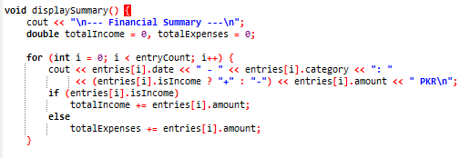

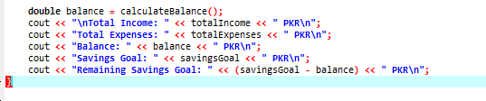
It loops through all transactions and displays details.

It calculates total income, expenses, and balance.

It compares the balance with the savings goal.

6. User Interface

The program runs in the console and presents users with a menu-driven interface:

--- Personal Finance Manager ---
1. Add Income
2. Add Expense
3. Set Savings Goal
4. Display Summary
5. Exit
Enter your choice:

Users can input their choice to perform actions accordingly.

7. Execution Flow

1. The program starts and displays the menu.
2. The user selects an option (1-5).
3. Based on the selection:
The user can add income or expenses.
Set a savings goal.
View a summary of their finances.
Exit the program.

4. The program continues to loop until the user chooses Exit (option 5).

8.Step by step explanation:

  - Step 1: Including Necessary Libraries

The `iostream` library is included for input/output operations.
- The `string’ library is included for string manipulation.

  - Step 2: Defining Constants and Structs
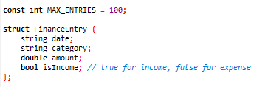
A constant MAX_ENTRIES is defined to limit the number of financial entries.
- A struct FinanceEntry is defined to store financial records, including date, category, amount, and income/expense status
  - Step 3: Declaring Global Variables
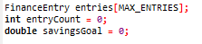
- An array entries is declared to store financial records, with a maximum size of MAX_ENTRIES.
- A variable `entryCount` is declared to keep track of the number of financial entries.
- A variable `savingsGoal` is declared to store the user's savings goal.

  - Step 4: Defining Functions
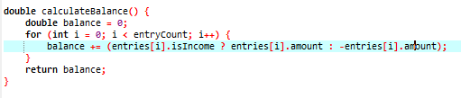
This function calculates the current balance by iterating through all financial entries and summing up the amounts
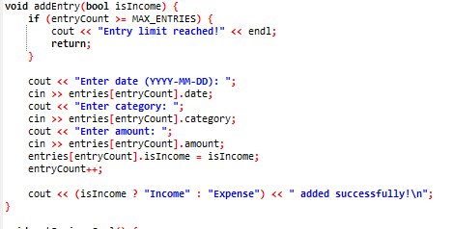
- This function adds a new financial entry, prompting the user for date, category, and amount.
- It checks if the entry limit has been reached and returns an error message if so.
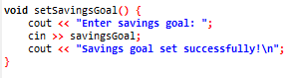
- This function sets the user's savings goal, prompting the user for input.
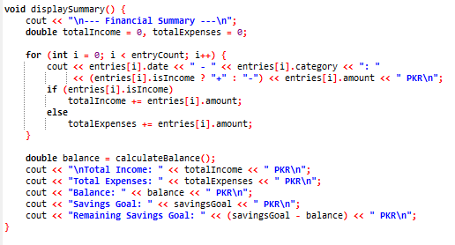
- This function displays a financial summary, including total income, total expenses, balance, savings goal, and remaining savings goal.

  - Step 5: Main Function
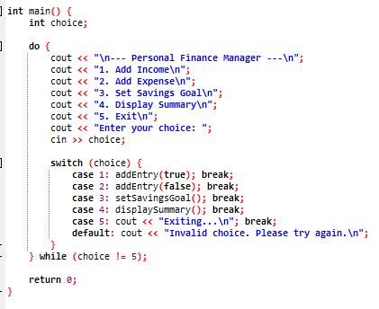
- The main function is the entry point of the program.
- It uses a do-while loop to repeatedly display a menu and prompt the user for input.
- Based on the user's choice, it calls the corresponding function (addEntry, setSavingsGoal,`displaySummary, or exits the program).
- If the user enters an invalid choice, it displays an error message and prompts the user to try again.

Example Use Cases
  - 1. Adding Income:

- User selects option 1 (Add Income) from the menu.
- User is prompted to enter the date, category, and amount of the income.
- The income is added to the list of financial entries.
  - 2. Adding Expense:

- User selects option 2 (Add Expense) from the menu.
- User is prompted to enter the date, category, and amount of the expense.
- The expense is added to the list of financial entries.
  - 3. Setting Savings Goal:

- User selects option 3 (Set Savings Goal) from the menu.
- User is prompted to enter the savings goal amount.
- The savings goal is set and displayed in the financial summary.
  - 4. Displaying Financial Summary:

- User selects option 4 (Display Summary) from the menu.
- The program displays a financial summary, including total income, total expenses, balance, savings goal, and remaining savings goal.

OUTPUT:
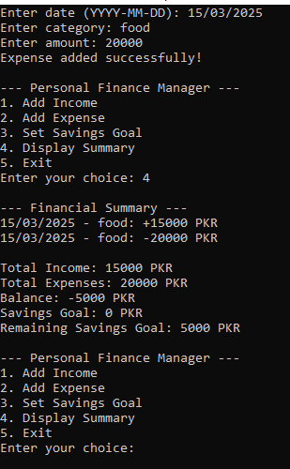

9. Limitations and Future Improvements

  - 9.1 Limitations

The program only stores a fixed number of entries (100).

Data is lost when the program exits because it does not use file storage.

The program does not support editing or deleting entries.

  - 9.2 Future Improvements

File Handling: Save and load data from a file to maintain records.

Dynamic Memory Allocation: Allow unlimited entries using vectors instead of fixed arrays.

Graphical Interface: Implement a GUI for a better user experience.

Entry Modification: Add options to edit or delete financial records.

10. Conclusion

The Personal Finance Manager is a simple but effective tool for tracking personal finances. It allows users to manage their income, expenses, and savings goals efficiently. Though basic, this project lays the foundation for more advanced financial applications.

This project demonstrates fundamental C++ programming concepts, including arrays, functions, loops, and conditional statements. With future enhancements, this system can become a more comprehensive financial tracking solution.

